Update on website design

- Theme colour:
Discussion: The preference is along the lines of our actual ldworkflows.com at present. Using pastel colours - not necessarily the same images but along the colour style of the current site
AIM: Bright catching front page when first open

- On the front page a leading design showing:

In a clockwise style around ERP in the center

So ERP and then around the ERP - CRM
Quotes
Sales Orders / Invoices
Purchasing
Accounts Payable
Accounts Receivables
Projects
Field Service
Warehouse Management
E-Commerce (Native sync with Shopify / Woo Commerce)
Finance / Accounting
Reporting
AI integrations

Use this version
[TS comments - too many options - stick to our core features - max 5]
CRM
Order to Cash - Quotes > Sales Orders > Invoices > Receivables
Procure to Pay - Quote > Purchase Order > Bills > Payables
Warehouse Management > Order fulfilment - define a flow with key process steps
E-commerce
Accounting
Reporting
AI integration
Field Service

- A design across the page showing the process from a sale to VAT returns to demonstrate the process (all in one) right to preparing a VAT return - (no human intervention)

E-Commerce sale - Warehouse Fulfilment - Invoicing - Finance - VAT Return

This could be a moving diagram
See example (only)


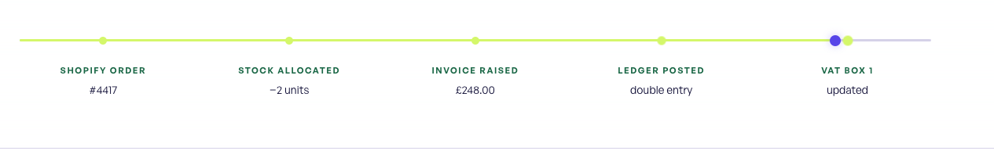

- A website style only to show how we can integrate with other systems
https://dokka.com/integrations/
Use Netsuite / Xero / Intuit Quickbooks / Woo Commerce / Shopify
Show logos for each of these
Example:
Netsuite (same with all)
Sync with (rename these to see above - see list around and including ERP)
products
customers
suppliers
invoices
warehouse management

- HMRC - Recognised for MTD

- Show logos for AI Gemini

- Show a menu at the top of the page - customers can select where they want to navigate to

- Then we could run separate pages (like a lead page on each topic example Netsuite / Xero / Quickbooks) for the items around the ERP or in the meantime we could start with CRM / Field Service as these are already in place. Use the companies own logo (labelled with their name)

- Criteria
    - show all key points on front page with links to another page with more detail.
    - Show contact details on front page plus use our contact us form https://my.lightdegree.com/crm/enquiries/40fbdacd-7c87-d2f0-f22e-e10264ad6b8b/external/?gid=0

